ASSIGNMENT-1
Discrete Probability Distributions — AIML Laboratory
Q1. Enter the data: Use the monitoring table to identify the failure rate and average alert count.
Answer:
Based on the experimental guidelines provided in the monitoring table, the core parameters identified for analysis are:
• Binomial Distribution Parameters: Number of trials n = 100, Probability of failure p = 0.0225.
• Poisson Distribution Parameters: Baseline average rate λ = 3 (with comparison values λ = 2 and λ = 5).
• Geometric Distribution Parameters: Probability of success p = 0.8.
Q2. Select Binomial: Set n = 100 and p = 0.0225. Calculate the probability of exactly 3 failures and view the PMF.
Answer:
1. Summary Statistics:
• Mean (μ) = n × p = 100 × 0.0225 = 2.25
• Variance (σ²) = n × p × (1 - p) = 100 × 0.0225 × 0.9775 = 2.20
• Standard Deviation (σ) = √(2.199375) = 1.48
• Second Moment E[X²] = σ² + μ² = 2.199375 + (2.25)² = 7.26
• Skewness = (1 - 2p) / σ = (1 - 0.045) / 1.483 = 0.64
2. Probability Calculation for Exactly 3 Failures (k = 3):
Formula: P(X = k) = C(n, k) · p^k · (1-p)^(n-k)
P(X = 3) = C(100, 3) · (0.0225)³ · (0.9775)⁹⁷
C(100, 3) = (100 × 99 × 98) / 6 = 161,700
P(X = 3) = 161,700 · 0.0000113906 · 0.11116 = 0.204739 (20.47%)
Result Interpretation: There is a 20.47% probability of observing exactly 3 failures in 100 trials.
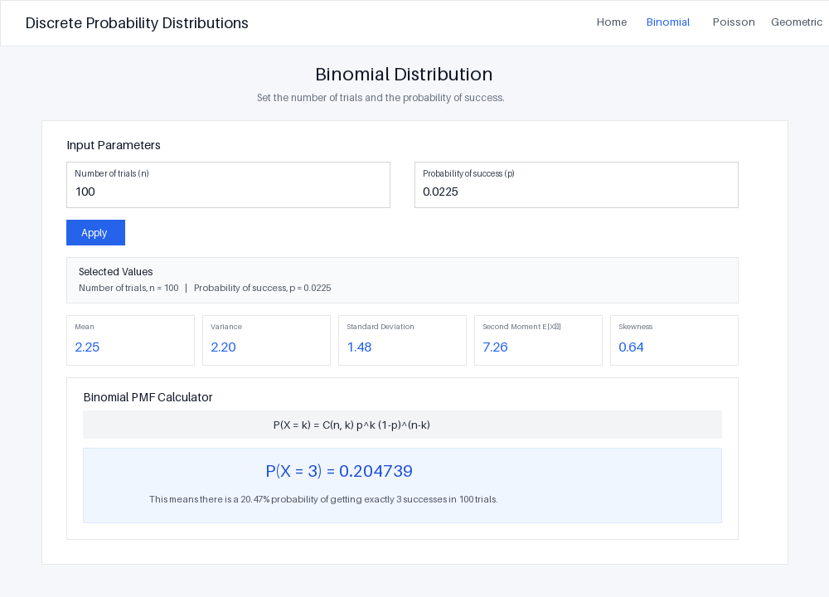
Figure 1: Binomial Distribution Module (n = 100, p = 0.0225, k = 3)
Q3. Select Poisson: Set λ = 3. Calculate the probabilities of 0, 1, 2, 3, and higher alert counts. View the graph.
Answer:
1. Summary Statistics for λ = 3:
• Mean (μ) = λ = 3.00
• Variance (σ²) = λ = 3.00
• Standard Deviation (σ) = √3 = 1.73
• Second Moment E[X²] = λ + λ² = 3 + 9 = 12.00
• Skewness = 1 / √λ = 1 / 1.732 = 0.58
2. Exact Probability Calculations (Formula: P(X = k) = e^(-λ) · λ^k / k!):
• P(X = 0) = e⁻³ · 3⁰ / 0! = 0.049787 (4.98%)
• P(X = 1) = e⁻³ · 3¹ / 1! = 0.149361 (14.94%)
• P(X = 2) = e⁻³ · 3² / 2! = 0.224042 (22.40%)
• P(X = 3) = e⁻³ · 3³ / 3! = 0.224042 (22.40%)
3. Cumulative and Higher Alert Probabilities:
• P(X ≤ 3) = 0.049787 + 0.149361 + 0.224042 + 0.224042 = 0.647232 (64.72%)
• P(X > 3) = 1 - 0.647232 = 0.352768 (35.28%)
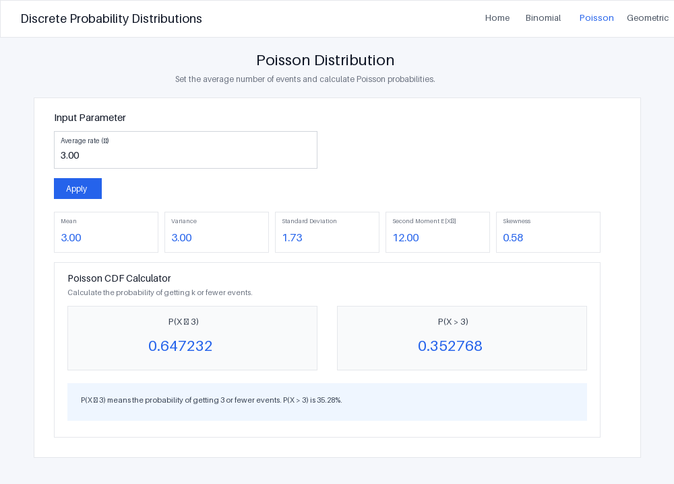
Figure 2: Poisson Distribution Module (λ = 3.0)
Q4. Experiment with λ: Compare λ = 2, λ = 3, and λ = 5. Observe how the distribution shifts as the average alert count increases.
Answer:
Metric / Parameter | λ = 2 | λ = 3 (Baseline) | λ = 5
Mean (μ) | 2.00 | 3.00 | 5.00
Variance (σ²) | 2.00 | 3.00 | 5.00
Standard Deviation (σ) | 1.41 | 1.73 | 2.24
Skewness | 0.71 | 0.58 | 0.45
P(X = 0) [Zero Alerts] | 0.135335 | 0.049787 | 0.006738
P(X > 3) [High Alerts] | 0.142877 | 0.352768 | 0.734974
Key Shift Observations:
1. Peak (Mode) Movement: As λ increases from 2 to 5, the peak bar shifts rightward toward higher event counts.
2. Increased Spread: Variance increases directly with λ (σ² = λ), which flattens and widens the probability distribution curve.
3. Increased Symmetry: Skewness drops from 0.71 down to 0.45, making the distribution visually and mathematically closer to a Normal curve.
Q5. Select Geometric: Set p = 0.8. Calculate the probability of success on the first, second, and third attempts.
Answer:
1. Summary Statistics for p = 0.8:
• Mean (μ) = 1 / p = 1 / 0.8 = 1.25
• Variance (σ²) = (1 - p) / p² = 0.2 / 0.64 = 0.31
• Standard Deviation (σ) = √(0.3125) = 0.56
• Second Moment E[X²] = (2 - p) / p² = 1.2 / 0.64 = 1.88
• Skewness = (2 - p) / √(1 - p) = 1.2 / 0.4472 = 2.68
2. Individual Trial Probabilities (Formula: P(X = k) = (1-p)^(k-1) · p):
• 1st Attempt (k = 1): P(X = 1) = (0.2)⁰ · 0.8 = 0.800000 (80.00%)
• 2nd Attempt (k = 2): P(X = 2) = (0.2)¹ · 0.8 = 0.160000 (16.00%)
• 3rd Attempt (k = 3): P(X = 3) = (0.2)² · 0.8 = 0.032000 (3.20%)
3. Cumulative Success within 3 Attempts: P(X ≤ 3) = 1 - (1 - 0.8)³ = 0.992000 (99.20%).
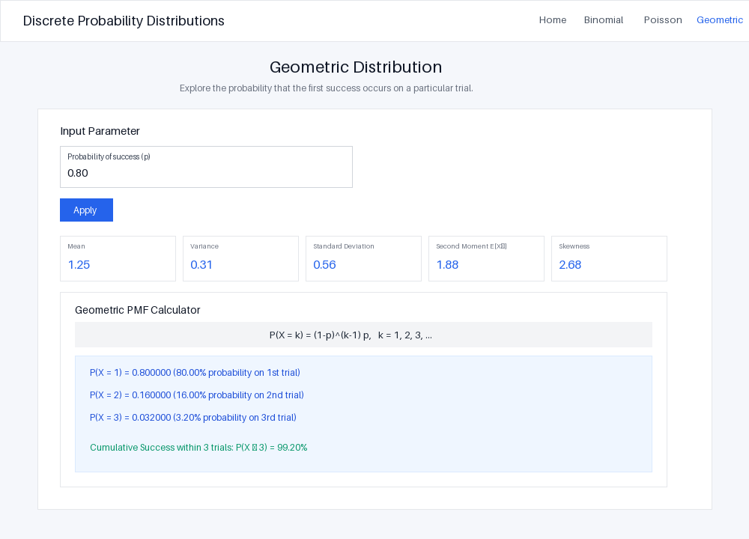
Figure 3: Geometric Distribution Module (p = 0.80)
Q6. Interpret the results: Discuss whether the calculated probabilities could help the operations team plan monitoring thresholds, investigate failures, or evaluate retry policies.
Answer:
1. Planning Monitoring Thresholds (Poisson Model):
Under standard operations with λ = 3, the probability of exceeding 3 alerts is P(X > 3) = 35.28%. Setting an alert threshold at k = 3 would lead to frequent false alarms. To avoid alert fatigue, the operations team should set threshold alerts at k ≥ 6 or 7 (where P(X ≤ 6) = 96.65%), ensuring that staff are alerted only during genuine operational surges.
2. Investigating System Failures (Binomial Model):
For n = 100 trials with a failure rate p = 0.0225, the expected mean number of failures is μ = 2.25. Observing exactly 3 failures carries a probability of 20.47%, which is normal operational variance. Emergency investigations should not be triggered for 3 failures. However, if failures exceed 6 or 7 in a batch (P(X ≥ 6) < 2%), an immediate incident investigation is required.
3. Evaluating Retry Policies (Geometric Model):
With a success rate of p = 0.8, 80% of requests succeed on the first attempt, 96% within two attempts, and 99.2% within three attempts. Capping retries at 3 attempts is mathematically optimal. Allowing 4 or more retries provides less than 0.8% marginal gain while running the risk of server overloading and network degradation.

